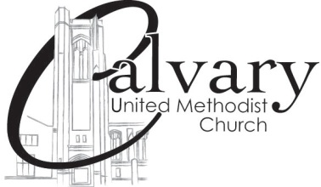
Calvary United Methodist Church
131 West Second Street, Frederick, Maryland 21701
301-662-1464 ● www.calvaryumc.org

Calvary United Methodist Church seeks and invites all to become disciples of Jesus Christ
for the transformation of our community and our world.

Ordinary Time
September 15, 2019 8:30 & 11 a.m. Worship Services

The following abbreviations are used in this bulletin:
UMH = United Methodist Hymnal (blue hardcover); TFWS = The Faith We Sing (black soft cover).

GATHERING

*Passing The Peace of Christ
The peace of Christ be with you.
And also with you.

Welcome and Announcements
We invite you to let us know you’re here today. Please record your attendance in the friendship pad and pass the book to those next to you. You can also indicate that you wish to receive our weekly e-newsletter.

Voluntary 8:30 “Arioso” J.S. Bach
(From Cantata 156) arr. Pakhomkin
Piotr Pakhomkin, guitarist

11:00 “Whoever Lets Our Dear God Rule” J.S. Bach
Please use this time to prepare to worship

*Call to Worship (read responsively)
Trust in the Lord and do good.
May the Lord give strength to the people.
O taste and see that the Lord is good!
God is our refuge and strength, a very present help in times of struggle.

*Hymn “Holy, Holy, Holy” UMH #64

Prayer of Confession (unison)
God, you are our refuge in times of trouble and the source of all our blessings in times of health and strength. Help us to live each day doing good to others and showing love to our neighbors. Help us avoid those things that lead us away from you and cause us to do harm to others or ourselves. Help us to live each day so that we do not cause others to stumble or lose their way.
Forgive us, compassionate God, and grant us the opportunity to start over again. Keep us from repeating the mistakes of the past or from new evils that could mislead to tear down. We pray all this in the precious name of Jesus Christ. Amen

Silent prayer

Assurance of Pardon
May Almighty God, who caused light to shine out of darkness, shine in our hearts, cleansing us from all our sins, and restoring us to the light of the knowledge of God’s glory, in the face of Jesus Christ, our Savior. Amen

THE WORD IS PROCLAIMED

Children’s Message
At the 8:30 Worship Service, Children’s Church is available for children Kindergarten through 3rd grade. This involves worship related activities for children. Parents are asked to escort their children to the Chapel to meet the Children’s Church leader for the morning. Children are also welcome to stay in the worship service.

Anthem 8:30 “Jesu, Joy of Man’s Desiring” J.S. Bach
(From Cantata BWV 147) arr. Pakhomkin
Piotr Pakhomkin

11:00 “I Worship You, Almighty God” Sondar Wood
Sanctuary Choir

*Gospel Lesson Luke 16:10-13
The Word of God for the people of God.
Thanks be to God.

*Hymn “How Firm a Foundation” UMH #529

Sermon Bringing More Balance to the Budget Rev. Steve Larsen
(Sermon Series: Finding Margins #3)

Moment for Reflection and Commitment

Our Response
Prayer for others

The Lord’s Prayer
Our Father, who art in heaven, hallowed be thy name. Thy kingdom come, thy will be done on earth as it is in heaven. Give us this day our daily bread. And forgive us our trespasses as we forgive those who trespass against us. And lead us not into temptation, but deliver us from evil. For thine is the kingdom, and the power and the glory, forever. Amen

We Offer Our Tithes and Gifts

Offertory 8:30 “Sinfonia” J.S. Bach
(From Cantata BWV 29) arr. Pakhomkin
Piotr Pakhomkin

11:00 “Give of Your Best to the Master” Charlotte Barnard
Joyce Summers & Joche Wilmot
arr. Mickelson/Atwood

*Doxology “Praise God, from Whom All Blessings Flow” UMH #94

*Prayer of Dedication

SENDING FORTH

*Hymn “Leaning on the Everlasting Arms” UMH #133

*Dismissal with Blessing

*Voluntary “Fantasy in C Major” J.S. Bach

*Going Forth to Serve

Sermon Series- Finding Margins Our lives are busy and fast-paced. The lack of margin increases our stress and shortens our tempers. Our busy-ness can distract us from what is most important. Our relationships suffer. It can even affect our connection with God. Life is better with margin and breathing room. The series concludes next Sunday with a sermon entitled “Breathing Room in Your Relationships” based on Ephesians 5:21-28. Previous sermons in the series can be found at www.calvaryumc.org.

The flowers on the altar are in celebration of Bob and Doris Keeney’s 52nd wedding anniversary, September 16 here at Calvary church by Rev. Sharpe.

We welcome this morning Russian-American guitarist, Piotr Pakhomkin. An award-winning musician, Piotr performs and gives master classes in Europe, Central America and in the U.S.A. He earned his Master’s Degree from the Peabody Institute.

Piotr lives in Frederick with his wife and child. He has founded his own teaching academy, and will be doing some of his teaching here at Calvary! See his website for more details: Segovia Academy of Music www.segovia-academy.org or 301-431-6934
Serving Schedule
Ushers:
8:30 a.m. 11:00 a.m.
David Mills Donald Orrison
Bret Slovikosky Gloria Orrison
Paul Nelson Greg Gray
Richard Delauter Rob Summers
Randy McClement

Today, Sunday, September 15 8:30 a.m. 11:00 a.m.
Greeter Austin Family Art and Carol Fennington
Lay Reader Didi Willard Dean Calcagni
Coffee Host Frank and Beth Strakonsky

Next, Sunday, September 22 8:30 a.m. 11:00 a.m.
Greeters Kile Family Staggs Family
Lay Reader Cindy Mills Ronda Dudley
Coffee Host Randy and Maryjane McClement

New picture directory Help us connect with each other and capture memories. The church is putting together a new picture directory and we do not want anyone left out. Photography will take place September 26, September 27 and September 28.

Please schedule an appointment for pictures today by visiting the church website (www.calvaryumc.org) and following the link or go to https://booknow-lifetouch.appointment-plus.com/yreq3nhs/. There will also be opportunities to sign up each Sunday morning before and after the worship in the Fellowship Hall.

Young Adult Dinner Theology join us for a lively evening every Tuesday, this week we will be meeting at Oscar’s at 6:30 p.m.

Church and Society Table talk is back, today, Sunday, September 15 and will be held in-between the 8:30 and 11:00 am services in the Parish Hall. The focus is on the broad array of social justice issues of importance to our ministry, with an invitation to members of our congregation who might have an interest in participating with us in addressing them.

VISTING WITH US?
Welcome! We are glad that you chose to worship with us this morning. More information about Calvary UMC is available in our welcome packets, or by speaking with a pastor or with someone at the Welcome Center in the Parish Hall.
- We invite you to sign in using the registration pads that are located in each pew. You can also use these pads to see who is sitting with you today.
- Please join us in the Parish Hall for fellowship following worship today!
- Nursery care available Sundays for children who are newborn-4 yrs. old.
- Join us on Facebook.
- Sermons are available on-line at our website- www.calvaryumc.org and our Facebook page.
- Large print bulletins and hymnals are available from the ushers.
Children’s Bulletins are available for children ages 3-6 and 7-12 that connect to the weekly sermon. These can be found in the coloring center in the Narthex or ask an usher for guidance.

Want to keep up to date with what’s happening? You can find the pastor’s blog, upcoming events, links to volunteer opportunities, recent pictures and more with our weekly email. Subscribe by sending a request to: office@calvaryumc.org

Prayer Concerns Names are added to this list by request. Please do your best to keep the office apprised of any changes in status. The list will be reviewed monthly and names removed unless you request otherwise. Email to office@calvaryumc.org. For all pastoral care concerns, please contact Pastor Steve at revsteve@calvaryumc.org or 301-662-1464 or via cell phone: 301-848-8216.

Recent Losses: Charles Brown (Brother of Gary Brown), Aubrey Dixon, Erich Muehl

Members of Calvary: Betty Fawley, Bruce Sheppard, Judy Johnson, Shirley Silbernagel, Pete Allen, Dean Calcagni, Lynn Schumacher, Ann Crum, Doris Felton, Joan Cooley, Buck Isaacs, Nancy Crum, Lee Sharpe, Owen Duthoy, Frank West, Fannie Johnson, Bob Strine, Mary Louise Schueler, Amy Carter, Michael Boyer

Friends of Calvary: Barbara Dotson (Friend of Bonnie Strine), Ed Kinsey, Jr (Father of Ed Kinsey), CW Waskey (Father of Bill Waskey), George Spadacino (Father of Anastasia Slovikosky) Brother of Melissa Rust, Bess Todd (Mother of Pat Herber), Wendy Koch (Niece of Bruce and Helen Sheppard), Shannon and Cody (Family members of Betsy Bryant), Alice Woodward( Sister of Rita Sharpe) Elsie Haynes (Friend of Rita Sharpe) Stanley (Friend of Rita Sharpe), Jeannie Whirley (Friend of Ron Dudley), Tom Van Pelt (Father of Beth Waskey & Becky Bostian), Eli Yanike(Great-grandson of Ramonia Yanike), Gay Ann Mazac (Niece of Steve and JoAn Ehlers), June Walden (Mother of Julie Schwarzenberg), Harriett Lakel (Sister of Anne Mossburg), Connie Steinhaus, Stanley Hula, Jr, Nancy Bozic, Ann Marable, Virginia Flyod, Joe and Yvonne Harris (friends of Rita Sharpe).

The UMW and the VIM Team are sponsoring a Diaper Drive- A collection of diapers of all sizes, pull-ups, and wipes for the Early Child Care Program at the Henderson Settlement in Kentucky. Please bring your donations to the cradle by the stage this month, September. Thank You!

Crafting for the 2019 Church Bazaar has begun. We need all hands on deck. Please consider helping the craft group this year. We meet Monday evenings 7:00-9:00 pm and Tuesday afternoons 1:00-4:00 pm. Hope to see you there. Questions???? Call Becky Isaacs 301-304-0439 (home) or 301-639-5377 (cell).
Pastor’s Bible Study
The Tuesday morning Bible Study led by Pastor Steve will begin on Tuesday, September 24 at 10 AM in the church library. It is a lively and fun group. All are welcome, no prior experience or Bible expertise required. Come learn more about what God has to say to us today as we pick up the Bible and read it together
What: Special Agent Training
When: Today, Sunday, September 15, 6:00 pm - 7:30 pm
Where: Mission Headquarters (AKA, the Activity Room of the Education Building

Exploring Membership Class Persons wishing to learn what it means to be a follower of Jesus Christ or interested in becoming a member of Calvary Church are invited to take part in an Exploring Membership class on Sunday mornings, September 15 and September 22 at 9:45 am. We will meet in the chapel. Pastor Steve Larsen will lead the class. We will consider the history and purpose of the church and look at what it means to have a vital and growing faith today. To let me know you’re coming or for more information, contact Pastor Steve at the church at 30-662-1464 or RevSteve@calvaryumc.org

Join us this summer for book discussions! If you like fiction, we are reading a few different kinds and would love to have you join us for conversation!
Sept. 18, 7:30 p.m. at Brewer's Alley "Naamah"

Care for Caregivers
Several individuals and families in the congregation are currently dealing with the challenges of caring for aging parents. This can involve health issues as well as many unexpected difficulties that come with aging. There can be a whole range of emotions that go along with switching places with those who once cared for you. Sometimes it just helps to know there are others on the same journey and you are not as alone as you thought. If you are interested in connecting with others who are facing similar issues, there will be an informal gathering to he held on Wednesday, September 25 at 7:30 p.m. in the John Wesley Room at the church. Those who might wish to have a time for quiet and prayer can come at 7:00 p.m. for Open Prayer in the chapel. If you are interested but can’t attend either, let me know at revsteve@calvaryumc.org or call the church office at 301-662-1464.

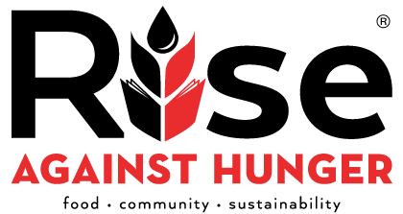
Calvary is going to Rise Against Hunger again as part of our second annual Weekend of Caring, October 12th from 10:00 am until noon. But we need your help to succeed! Donations of time and financial contributions are both important.
Give what you can and watch what God can do with your gift once it is added to everyone else’s! Sign up or contribute toward the food we will pack:
https://rah.secure.force.com/events/homepage?id=7013Z0000025mLkQAI

This Week at Calvary, September 15-September 22

Today, Sunday September 15
8:30 a.m. Worship
9:45 a.m. Sunday School for all ages
11:00 a.m. Worship
12:30 p.m. Children’s Choir
3:00 p.m. Community Concert Series
4:30 p.m. Youth Council Meeting
5:30 p.m. Youth Group
6:00 p.m. Mission Possible Kids

Monday, September 16
7:00 p.m. Finance Committee

Tuesday, September 17
1:30 p.m. Wesleyan Circle Meeting
6:00 p.m. Yoga
6:30 p.m. Dinner Theology- Young Adults
6:30 p.m. Joyful Noise Handbell’s
7:30 p.m. Sanctuary Choir

Wednesday, September 18
1:00 p.m. CWS Steering Committee
6:30 p.m. Men’s Bible Study
7:00 p.m. Open Prayer
7:30 p.m. Summer Book Club at Brewer’s Alley

Thursday, September 19
6:30 p.m. AGAPE
6:30 p.m. Committee of Lay Leadership
7:00 p.m. Education Ministry (Baker Center)

Friday, September 20
7:00 p.m. Youth Mission Lock-In

Saturday, September 21
5:00 p.m. Calvary at the Soup Kitchen

Next Sunday, September 22
8:30 p.m. Worship
9:45 a.m. Sunday School
11:00 a.m. Worship
12:30 p.m. Children’s Choir

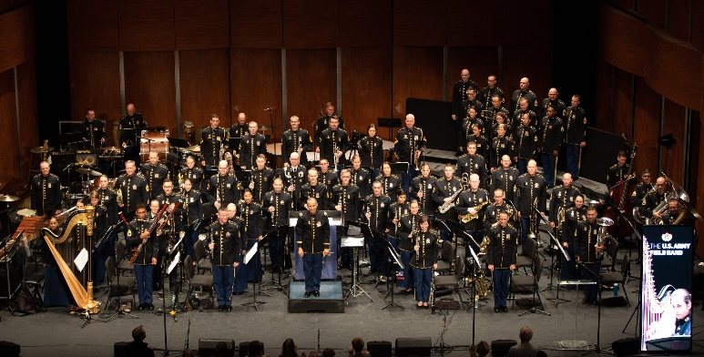
Calvary Community Concert Series

The United States Army Field Band
Chamber Concert featuring various performers from the Concert Band and Soldier’s Chorus

Sunday, September 15 at 3:00 p.m. (doors open at 2:30 p.m.)

