**Calvary United Methodist Church**

131 West Second Street, Frederick, Maryland 21701

301-662-1464 ● [www.calvaryumc.org](http://www.calvaryumc.org)

*Calvary United Methodist Church seeks and invites all to become disciples of Jesus Christ for the transformation of our community and our world.*

March 3, 2024 3rd Sunday in Lent 10:00 A.M. Worship Service

Prelude

*Passing the Peace

The peace of the Lord be with you.

**And also with you.**

Welcome, announcements

*Call to Worship(read responsively) from Psalm 95:1-2

O come, let us sing to the LORD;

**Let us make a joyful noise to the rock of our salvation!**

Let us come into God’s presence with thanksgiving;

**Let us make a joyful noise to him with songs of praise!**

*Hymn “Jesus Lover of My Soul” UMH #479

Opening Prayer (said together)

**Almighty God,**

**to you all hearts are open, all desires known,**

**and from you no secrets are hidden.**

**Cleanse the thoughts of our hearts**

**by the inspiration of your Holy Spirit,**

**that we may perfectly love you,**

**and worthily magnify your holy name,**

**through Christ our Lord. Amen**

Scripture Lesson Ephesians 2:1-10 Karen Gebhart

*Gospel Lesson John 3:14-21 Karen Gebhart

*Response

The word of God for the people of God.

**THANKS BE TO GOD.**

Time With the Children

*Following the Time with the Children, all children in K-3rd grade are invited to Children's Church either in the Chapel or in the Nursery for the remainder of the worship service. Parents are asked to walk their children to narthex/lobby where they will find the children’s church leader.*

*Hymn “The King of Love My Shepherd Is” UMH #138

Sermon Rev. Steve Larsen

Who Do You Say That I Am?Jesus as SAVIOR

Time for Reflection and Commitment

Prayers of the People

Invitation

Confession and Pardon (said together)

**Merciful God,**

**We confess that we have not love you with our whole heart.**

**we have failed to be an obedient church.**

**we have not done your will,**

**we have broken your law,**

**we have rebelled against your love,**

**we have not loved our neighbors,**

**and we have not heard the cry of the needy.**

**Forgive us we pray.**

**Free us for joyful obedience,**

**through Jesus Christ our Lord. Amen**

Silent Prayer

Pardon and Forgiveness

Hear the good news:

Christ died for us while we were yet sinners;

That proves God’s love toward us.

In the name of Jesus Christ, you are forgiven!

**In the name of Jesus Christ, you are forgiven!**

**Glory to God. Amen**

Offertory

*Our giving to God and the church is one more way we worship God.*

*There are several ways to give. In addition to putting our offering in the offering plates, checks can be sent to the church office at 131 West 2nd St, Frederick, MD 21701. Online payments can be made easily and securely by going to* [*www.Calvaryumc.org/give/*](http://www.Calvaryumc.org/give/) *or by using the QR code on the back of this bulletin. You can make a one-time gift or set up ongoing electronic payments. ACH payments can also be set up using the form on the church website or in the information stand in the narthex. Please use this time to register your attendance here today in the red folders found in the pews.*

*Doxology UMH #64, st. 4

**Holy, holy, holy! Lord God Almighty!**

**All thy works shall praise thy name, in earth and sky and sea.**

**Holy, holy, holy! Merciful and mighty,**

**God in three persons, blessed Trinity.**

*The Great Thanksgiving (Musical Setting A) UMH, p. 17-18

The Lord be with you.

**And also with you.**

Lift up your hearts.

**We lift them up to the Lord.**

Let us give thanks to the Lord our God.

**It is right to give our thanks and praise.**

…and so, with you people on earth and all the company of heaven, we praise your name and join their unending hymn:

**Holy, holy, holy Lord, God of power and might,  
heaven and earth are full of your glory.  
Hosanna in the highest.  
Blessed is he who comes in the name of the Lord.  
Hosanna in the highest.**

…and so in remembrance of these your mighty acts in Jesus Christ… as we proclaim the mystery of faith.

**Christ has died; Christ is risen; Christ will come again**

…all honor and glory is yours, almighty God, now and forever.

**Amen, amen, amen.**

The Lord’s Prayer

**Our Father, who art in heaven, hallowed be thy name. Thy kingdom come, thy will be done on earth as it is in heaven. Give us this day our daily bread. And forgive us our trespasses as we forgive those who trespass against us. And lead us not into temptation but deliver us from evil. For thine is the kingdom, and the power and the glory, forever. Amen**

Sharing at the Lord’s Table

Prayer after Receiving

*Hymn “Lord, Dismiss Us with Thy Blessing” UMH #671

*Dismissal with Blessing

*Postlude

*Going Forth to Serve

______________

Worship Series: **Who Do You Say That I Am?**

Throughout the season of Lent, we will be considering different ways that Jesus Christ is viewed and encountered. Using *Freeing Jesus,* by Diane Butler Bass (New York: HarperOne: 2021), scripture and other resources we will look at several of ways to rediscover the fullness of Jesus for our lives today.

**Ushers:** Richard Delauter, Fran Haller, Judy Wilson, Paul Muehl, Dave Mills

**Acolyte:** Michael Mills

**Coffee Time Hosts:** Paul Nelson

**\*\*Attention**- The Nursery will temporarily be meeting in the Education Building from 10 – 11 a.m. during the worship service.

***Acolytes Needed:*** Dates have been added to the sign up list! Please use this link to sign up: <https://www.signupgenius.com/go/4090b4aa9a82aa4ff2-acolyte/18827003#/> If you have any questions please contact Stefanie Harris at [jujubee820@yahoo.com](mailto:jujubee820@yahoo.com)

***Children’s Church*** is for children in grades K-3, and takes place in our chapel during the worship service, immediately following the *Time with the Children.* If you would like to volunteer as a Children’s Church Adult please sign up at: <https://www.signupgenius.com/go/10c0949acad2fabfbc61-childrens>

*If there is not an adult present in the Chapel, please walk over to the Education Buildings Activity Room where the Nursery will be held temporarily.*

**Week of March 3 ~March 10**

**Today, Sunday, March 3**

9:00 a.m. Sunday School

9:00 a.m. New Members Class

10:00 a.m. Worship

11:00 a.m. Backpacking Event/MKP

11:00 a.m. Prayer Shawl Ministry

11:15 a.m. Children’s Choir

**Monday, March 4**

7:00 p.m. SPRC

**Tuesday, March 5**

10:00 a.m. Pastor’s Bible Study

1:30 p.m. UWF Ex. Committee

6:00 p.m. Youth Pancake Dinner

6:30 p.m. Joyful Noise Ringers

7:30 p.m. Sanctuary Choir

**Wednesday, March 6**

6:00 p.m. Lenten Study

**Thursday, March 7**

5:30 p.m. The Birthing Group

**Saturday, March 9**

7:30 a.m. Men’s Breakfast

**Next Sunday, March 10**

9:00 a.m. Sunday School

9:00 a.m. New Member Class

10:00 a.m. Worship

11:15 a.m. Children’s Choir

5:30 p.m. Youth Group

**Exploring Membership Class**

Persons wishing to learn what it means to be a follower of Jesus Christ or interested in becoming a member of Calvary United Methodist Church are invited to take part in an Exploring Membership class on Sunday morning at 9 AM on **March 3 and 10.** We will meet in the Parish Hall. Pastor Steve Larsen will lead the class to consider the history and purpose of the church and what it means to have a vital and growing faith.

**Children’s Ministry**

**Mission Possible Kids** is for kids in Kindergarten through 5th Grade who want to help others and make a difference in the world! Mission Possible Kids will not meet in March, but we will be helping Calvary’s Youth on **Sunday, March 3** from **11:00 - Noon** in the Parish Hall to help fill Blessings in a Backpack! J Please contact [AmyStone@calvaryumc.org](mailto:AmyStone@calvaryumc.org) for more information and to order a Mission Possible Kids t-shirt.

***Veggie Tale Movie Night***

Our next Veggie Take Movie night will be from **6 – 7 p.m.** **Friday, March 15** from in the Activities Room of the Education Building. Join us for pizza, a movie, discussion, a craft and more! Wear your pajamas and bring a blanket and pillow if you would like! Please register by contacting [AmyStone@calvaryumc.org](mailto:AmyStone@calvaryumc.org), or sign up in Sunday School.

**Please join us for our** **Family Easter Celebration!**

**Where: Parish Hall** **and Memorial Park**

**When:** **Saturday, March 30 1:00 – 3:00 pm**!

**Games ~ Crafts ~ Snacks ~ Easter Egg Hunt**

**A Visit from Ms. Bunny!**

**Donations of Easter candies and small toys for our**

**Easter Egg Hunt will be collected from February 25 – March 24.**



Calvary is going to see **DANIEL! Live On Stage!**

*in Lancaster PA* at *Sight and Sound Theater*

3 p.m. Saturday, August 10, 2024  
Note the time change to the afternoon show!  
(We will be having lunch before the show in Lancaster).

We were able to reserve a few extra seats, so if you are interested in joining us, please contact [AmyStone@calvaryumc.org](mailto:AmyStone@calvaryumc.org).

(Adults $89, Children 12 and under $39) - *Payment will be due at a later date.*

<https://www.sight-sound.com/shows/lancaster/daniel/2024>



**Mark your calendars for this summer’s SCUBA VBS!**

**June 17 – June 20, 2024**

Registration begins April 1. Please let Amy Stone know if you will be able to volunteer!

**Youth Ministry**

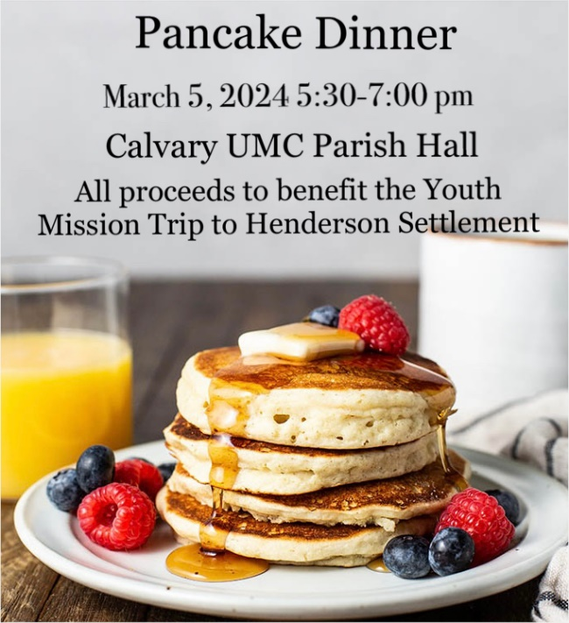

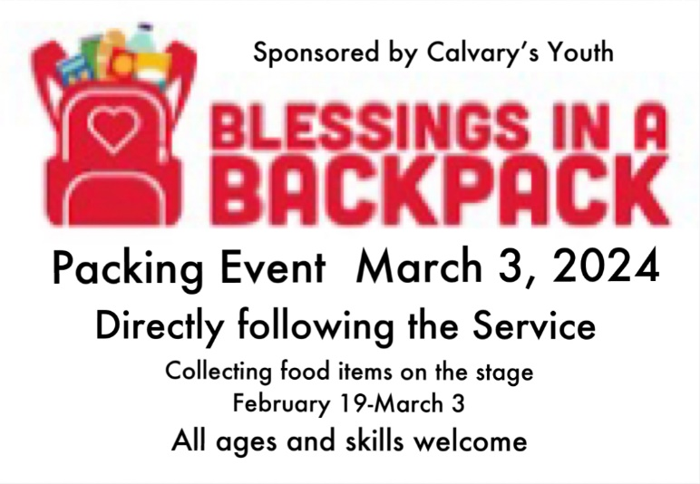

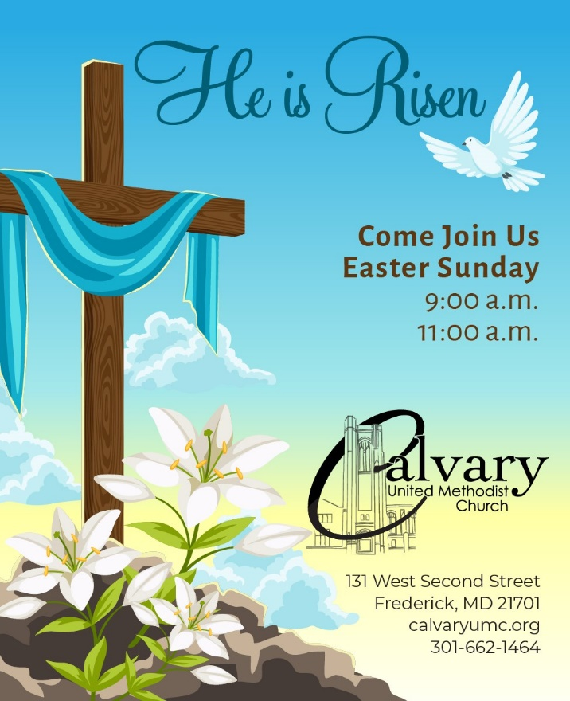

**Prayer Concerns:**

**Recent Passing:** Betty Brewer

**Members of Calvary:** Scott Officer,Charlotte Pasquerette,Marilyn Moyers,Josie Cottone,Basil Eavey, Peggy Griffee, Todd Main, Dick Alsmeyer, Ramona Yanike, Rita Sharpe, Nancy Dobbs, Nancy Crum, Judy Allen, Lois Pacheco, Joyce Dixon, Eleanor Bowersox, Susan Howe, Reed Keirn

**Friends of Calvary:** Abby Leach (Friend of the Family Circle Class), John and Dottie Stenner, Donnie Green (former member), Sarah Jenkins (Sister of Mary Crum), Cheryl Christine (Chris) Irving (Wife of Drew Irving), Patty Lockard (Weekday School Director), Steve Twiss (Brother of Margie Wilde), Allan Huffman (Son of Nancy Huffman), Brian Jones (Friend of the Linda & Scott English), Scott Berry, Joey Nichols (Friends of Paul Nelson), Erik Karl (Son of Cathy Karl), Janet Stone (Mother of Jeff Stone), Hope Patterson and Cathy Short (Sisters of Charlotte Pasquerette), Ken Kessel (Brother of Susan Baggette), Audrey Cash (Friend of Helen Sheppard), Kitty and Jack Cooley (Sister and brother-in-law of Connie Scoggins), Suzanne Simpson and Adam Shake (Sister & brother-in-law to Christy Mossburg), John and Lynn Mills (Friends of Charles Geisbert), Linda Horinie Henke (Niece of Charles Geisbert), Alice, Marion and Becky Woodward, family members of Rita Sharpe, Hannah Addair, Virginia Painter Floyd, Jill Sizemore, Anne Hovis, Gil Crippen, Rhonda Wills, Ann Kushick , Jim Clark, June Tucker and family, friends of Rita Sharpe

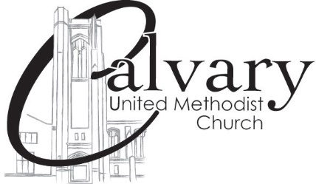

131 West Second Street

Frederick, Maryland 21701

301-662-1464 or office@calvaryumc.org

**Church Staff**

Rev. Dr. Steve Larsen, Lead Pastor Rev. Ken Humbert, Visitation Pastor

revsteve@calvaryumc.org or 301-848-8216 revkenh@starpower.net

Dr. Adela Peeva, Director of Music Ministries Jenn Duthoy, Director of Youth Ministries

adela@calvaryumc.org calvaryyouth@calvaryumc.org

Amy Stone, Director of Children’s Ministry Cathy Baker, Office Manager

AmyStone@calvaryumc.org cathybaker@calvaryumc.org

Bob Jacobs, Financial Secretary Paul Metcalf, Custodian

bobjacobs@calvaryumc.org paulmetcalf@calvaryumc.org

Joyce Summers, pianist

**Calvary Weekday School**

133 West Second Street, Frederick MD 21701

301-662-6783 ~ [www.calvaryweekdayschool.com](http://www.calvaryweekdayschool.com)

Patricia Lockard, Director Olivia Watkins, Administrative Assistant

director@calvaryweekdayschool.com [calvaryweekdayschool@calvaryweekdayschool.com](mailto:calvaryweekdayschool@calvaryweekdayschool.com)



Use this code to give online,

or visit our website at www.calvaryumc.org/give